Chemically tunable 2D Materials

Kristie J. Koski

Department of Chemistry, University of California Davis, Davis CA USA 95616
koski@ucdavis.edu

Two-dimensional (2D) materials, such as layered chalcogenides, graphene, and oxides, are an exciting new class of materials with extraordinary physical and chemical behaviors. These high-performance materials have the potential to enable an entire fleet of new technological applications ranging from electronics to photonics. To realize this potential requires (i) the synthesis of novel, high-quality 2D materials, (ii) a broad spectrum of chemical modification techniques, and (iii) a thorough understanding of how these modifications control the material physics. In this presentation, I will show new synthetic growth methods to create high-quality 2D chalcogenide materials including a new semiconductor, Si2Te3. I will present a novel chemical method to reversibly intercalate and deintercalate high concentrations of multiple, zero-valent atoms into 2D materials. The zero-valent nature of the intercalant species allows for high-density intercalation of metal atoms (Ag, Au, Co, Cu, Fe, In, Ni, and Sn) effectively doubling the number of atoms of the material. This method achieves unique physics including Pokrovsky-Talapov transitions, sliding charge density waves, and modified phononic behaviors. Finally, I will show how this work achieves opto-electronic application such as color-changing Smart Materials.

Biography
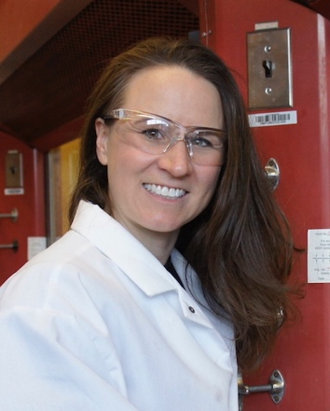
Dr. Kristie J Koski graduated from the University of Wyoming in 2002 with a B.S. in Physics and a B.S. in Chemistry. She attended graduate school at the University of California Berkeley followed by a postdoctoral position at Arizona State University and a second position at Stanford University. Her research currently focuses on 2D materials and on Brillouin spectroscopy. Dr. Koski has received the NSF CAREER Award and is funded by the Office of Naval Research. When not doing science, Professor Koski is an adrenaline junky known for surfing massive waves, rock-climbing, and driving her over-powered muscle car way too fast.

